Line spacing in the whole document is double spacing.
Margins must be 0.5 inch and font size 12 pts throughout the whole document.

An Assessment of Effective Measures for the Reduction of the Employee Rate of Turnover
Web-Based Vaccination Scheduling and Notification System with Pharmacy Integration

STUDENT ID: 2106656
STUDENT NAME: Augustine Nguzayikona
YEAR: 2021

A Research Project Proposal Submitted in Partial Fulfilment of the Graduation Requirements for the Northrise University Bachelor of Information Techmology in Web and Software Development.
Date Submitted: April 12, 2026.

Note: This page must be left blank

Declaration
(Place Your Declaration Below)
I Augustine Nguzayikona hereby declare that this paper represents my own work which has been done after registration for the degree of Bachelor Information Technology in Web and Software Development at Northrise University, and has not been previously included in a thesis or dissertation submitted to this or any other institution for a degree, diploma or other qualifications. I have read the University’s current research ethics guidelines and accept responsibility for the conduct of the procedures in accordance with the Student Handbook. I have attempted to identify all the risks related to this research that may arise in conducting this research, obtained the relevant topic approval and acknowledged my obligations and the rights of the participants.

Signed: Augustine Nguzayikona
Date: April 12, 2026

Abstract
Pediatric healthcare delivery in Zambia is still compromised by ineffective appointment scheduling systems, insufficient patient communication channels, and a lack of integration with hospital pharmacy operations. This leads to missed vaccination appointments, incomplete immunization cycles, and decreased clinical preparedness. This study develops and assesses a Web Based Vaccination Scheduling and Notification System with Pharmacy Integration to address the ongoing problem of high missed immunization rates in pediatric wards in Ndola, Zambia. The study will be carried out at Institute 1 using a pre test/post test evaluation design in conjunction with a Design Science Research (DSR) methodology. Twelve purposely selected healthcare professionals, including pediatric nurses, pharmacy employees, and administrative staff, will participate in semi-structured interviews to gather functional and non-functional system needs.
The Socio Technical Systems (STS) Theory, which highlights the cooperative optimization of social and technical subsystems for effective digital health deployment, serves as the study's foundation. Automated SMS reminders, centralized appointment scheduling, a pharmacy dashboard for vaccine demand predictions, and real time stock monitoring capabilities are some of the system's key features. To ascertain statistical significance, data analysis will use paired t tests or Wilcoxon signed rank tests to compare pre-test and post-test missed dosage rates.
Keywords: Vaccination Scheduling, Pharmacy Integration, Digital Health, Immunization Adherence, Pediatric Healthcare, Socio-Technical Systems Theory, Ndola Zambia, Design Science Research, Pre-test/Post-test Design, Health Information Systems

The table of contents must be auto generated.
Each time you add a headed section, update the table of contents (ToC) and reformat it to Times New Romans, 12 pts font size, changing text from bold to normal, restore line spacing to double spacing.
Table of Contents
Declaration 3
Abstract 4
List of Tables 7
List of Figures 8
List of Abbreviations 9
Chapter 1: Introduction 1
Research Background 1
Problem Statement 2
Purpose Statement 3
Research Questions 4
Significance of the Study 5
Definitions of Terms 5
Conclusion 5
Chapter 2: Literature Review and Conceptual/Theoretical Framework 6
Literature Review 6
Conceptual/Theoretical Framework 7
Conclusion 8
Chapter 3: Research Methodology 9
Research Method and Design 9
Research Procedure 10
Study Population and Sampling 10
Data Collection and Recording 10
Trustworthiness 11
Research Limitations 12
Delimitations 12
Data Analysis 12
Ethical Consideration 13
Conclusion 13
References 14
Appendix A 16
Appendix B 17
Appendix C 19

List of Tables
(Place an auto generated list of tables below. If you do not have tables in your document, do not include this page.)
To insert a list of tables, choose the references tab in Word and click on “Insert Table of Figures”. In the dialog box that appears, ensure that the Caption label is set to Table and click OK. All the table labels and their corresponding page numbers will appear without their table descriptions. Manually type the table descriptions preceded by a full colon and followed by one character spacing after the description; before the dotted line. The example is given below. You have to manually type the level one heading “List of Tables” and set it to level one heading so that it is picked as level one heading in the table of contents. Ensure that the list of tables is set to 12 points font size.

List of Tables
Table 1: Gantt Chart showing project timeline 5
Table 2: Example table one 7

List of Figures
(Place an auto generated list of tables below. If you do not have graphics in your document, do not include this page)
To insert a list of figures, choose the references tab in Word and click on “Insert Table of Figures”. In the dialog box that appears, ensure that Caption label is set to Figure and click OK. All the figure labels and their corresponding page numbers will appear without their figure descriptions. Manually type the figure descriptions preceded by a full colon and followed by one character spacing after the description; before the dotted line. The example is given below. You have to manually type the level one heading “List of Figures” and set it to level one heading so that it is picked as level one heading in the table of contents. Ensure that the list of figures is set to 12 points font size.
List of Figures
Figure 1: Flowchart as demo figure 9

List of Abbreviations
(Place a list of all abbreviations used in the document in alphabetical order. An example is given below. The example below should come immediately after the heading List of Abbreviations.)

Abbreviation Definition
ANOVA Analysis of Variance
CI Confidence Interval
CSV Comma Separated Value

Chapter 1: Introduction

Research Background
[3-4 paragraphs]
Ineffective appointment scheduling, and a lack of coordination between clinical departments continue to be problems for healthcare systems around the world. Healthcare facilities in many underdeveloped nations, including Zambia, still handle patient appointments using partially manual or disjointed digital systems. Overcrowding, delayed service delivery, and lower patient satisfaction are frequently the outcomes of these inefficiencies. According to recent research, inefficient scheduling systems seriously impair healthcare workflows and have a detrimental influence on service quality by preventing healthcare providers from coordinating with one another (Al-Kahtani et al., 2021).
The problem is made worse in pediatric healthcare settings by the need for coordinated and timely follow up care, particularly for immunization programs. To ensure treatment effectiveness and prevent disease outbreaks, vaccination regimens must be strictly adhered to. However, unorganized follow up procedures and insufficient reminder systems lead to missed appointments and incomplete vaccination rounds. Lower vaccination schedule adherence has been demonstrated to be significantly influenced by inadequate follow up management systems, especially in healthcare settings with limited resources (Gagnon et al., 2016).
Despite these developments, many healthcare institutions in developing regions have not fully adopted integrated digital systems, leaving gaps in efficiency and service delivery. Evidence suggests that SMS-based reminders and digital notification tools significantly improve appointment attendance and patient compliance with treatment plans. These technologies help reduce missed appointments and enhance communication between patients and healthcare providers, ultimately improving healthcare outcomes (Al-Kahtani et al., 2021).
The lack of connection between hospital pharmacy operations and appointment scheduling systems is another serious problem. The timely supply of vaccinations and drugs is essential for the efficient delivery of healthcare, especially in immunization programs. However, inadequate coordination between pharmacy inventory systems and clinical scheduling frequently results in treatment delays or stock shortages. Research highlights how combining pharmacy administration with health information systems boosts clinical readiness, guarantees drug availability, and improves resource planning (Gagnon et al., 2016). Despite these results, many local healthcare settings including those in Ndola, Zambia continue to deploy such integrated systems to a limited extent.

Problem Statement
[1 paragraph]
Long patient treatment delayed times, missed vaccination appointments, and inadequate clinical readiness in pediatric wards are still caused by inefficient appointment scheduling systems, insufficient patient communication mechanisms, and a lack of connection with hospital pharmacy systems. Many healthcare facilities, especially in underdeveloped nations like Zambia, still rely on disjointed or manual processes that lower efficiency and coordination despite advances in digital health technologies. According to recent research, poor communication and fragmented scheduling systems have a major impact on patient flow and service delivery, resulting in delays and lower-quality care (Al-Kahtani et al., 2021). Missed appointments and inadequate follow up methods often result in incomplete vaccine cycles in pediatric healthcare, raising children's health risks. Treatment is further disrupted by the lack of integration between pharmacy operations and scheduling systems, which often result in shortages of medications or immunizations at the point of service. An integrated web-based vaccination appointment scheduling and notification system with pharmacy integration must be created and tested in order to decrease incomplete vaccine rounds and enhance clinical readiness. Patients, Guardians s, medical staff, and hospital management are all impacted by this problem. If ignored, it can keep causing inefficiencies, missing vaccination doses, and subpar medical results.

Purpose Statement
[One paragraph stating the purpose and a maximum of three SMART objectives]
The purpose of this research is to develop a Web-Based Vaccination Appointment Scheduling and Notification System with pharmacy integration in specific pediatric wards in Ndola, Zambia, using a pre-test/post-test research design. The goals of this study are to,
- Using the Socio Technical Systems (STS) theory and the Health Information Systems (HIS) framework as a reference, to develop a web-based vaccination appointment scheduling and notification system to decrease missed vaccine doses in Ndola's pediatric wards over a predetermined study period;
- To implement a pharmacy integration capabilities that allow the pharmaceutical department to remain informed about future vaccine treatment drug needs;
- Use objective appointment and completion data to determine whether the method results in a quantifiable decrease in missed vaccination doses.

Research Questions
[Maximum of 250 words]
The main Research Question
How can the high rate of missed immunizations in Ndola, Zambia, be reduced, particularly in the pediatric ward?
Research Questions
- How can the number of missed immunization doses in Ndola's pediatric wards be decreased using a web-based vaccination appointment scheduling and notification system?
- What improvements can help a hospital's pharmacy department keep up with the demand for immunization therapy drugs in the future?
- Based on objective appointment and completion data, can the system show a quantifiable decrease in missed vaccination doses?

Significance of the Study
[2 - 3 paragraphs]
This study or research is important because it tackles ongoing issues with pediatric healthcare delivery, especially in Ndola, Zambia, where inadequate patient follow up, ineffective appointment scheduling, and a lack of integration with pharmacy operations lower care quality. This study intends to enhance patient flow, shorten treatment delayed times, and guarantee prompt administration of vaccines and drugs by creating and assessing a Web-Based Vaccination Appointment Scheduling and Notification System with pharmacy integration. It is anticipated that effective appointment scheduling will improve clinical readiness and maximize the utilization of medical resources, ultimately improving pediatric patients' health outcomes.
Important participants in this study include hospital management, medical staff, and patients and their caretakers. Patients and Guardians s will benefit from prompt reminders and improved adherence to immunization regimens, which will reduce the likelihood of treatment cycles that are not finished. The web based solution is intended to coordinate appointment information with pharmaceutical departments and monitor planned immunizations. This study's major objective is still to reduce missing immunization doses, not to alter administrative duties or workflow coordination. System generated data can be used by hospital administration to forecast future vaccine demand and adjust pharmacy inventory.
If such a system is not investigated and put into place, inefficiencies could continue, leading to missed appointments, overcrowded pediatric wards, and treatment delivery delays. Drug shortages could persist due to inadequate communication between pharmacy and clinical departments, jeopardizing patient safety and clinical preparedness. By filling up these gaps, the study offers workable solutions that may be expanded or modified for use in other Zambian healthcare institutions and comparable settings, making it a vital addition to both regional healthcare development and more general research on digital health systems.

Definitions of Terms
[Maximum of 250 words]
Web-Based Vaccination Appointment Scheduling System: An online platform that allows patients and Guardians s to schedule, reschedule, and receive vaccination appointment alerts (Al-Kahtani et al., 2021).
Clinical readiness: is the ability of medical personnel and facilities to deliver prompt and efficient care, including the availability of drugs and vaccines at the point of care (Gagnon et al., 2016).
Pharmacy integration: is the process of coordinating and connecting clinical appointment scheduling with pharmacy inventory systems to guarantee that patients receive their drugs and immunizations on time (Ugandan Ministry of Health, 2018).
Socio-Technical Systems (STS) Theory: A theoretical framework that contends that interactions between people, technology, and workflows affect organizational performance and that alignment between these components is necessary for the best results (Gagnon et al., 2016).
The Health Information Systems (HIS) Framework is a conceptual paradigm that describes how organized digital systems enhance the delivery of healthcare by facilitating prompt access to patient data, improving decision-making, and boosting departmental coordination (Al-Kahtani et al., 2021).
The degree to which patients adhere to their planned immunization sessions, including finishing all necessary doses within the advised timeframe (Silver et al., 2014).
Workflow Efficiency: How well clinical and administrative procedures control patient flow, minimize delays, and maximize medical resources (Al-Kahtani et al., 2021).

Conclusion
[200 to 250 Words]
This study's or research goal was very clear: to use a pre-test/post-test research strategy to create a Web-Based Vaccination Appointment Scheduling and Notification System with pharmacy integration. Reducing patient treatment delayed times, increasing appointment compliance, boosting clinical readiness, and evaluating user opinions of system effectiveness, dependability, and usability are some of the specific goals. With an emphasis on patient outcomes, pharmacy integration, workflow efficiency, and stakeholder perspectives, the research questions were developed to direct data collection and analysis.
By identifying important stakeholders patients and Guardians s, medical staff, and hospital administration and showing how each stands to gain from better scheduling, prompt notifications, and better resource coordination, the study's significance was established. To guarantee uniformity and clarity throughout the research, key keywords were defined.
By placing the issue in context and outlining the objectives of the study, this chapter has established a strong basis for the investigation. By reviewing pertinent literature, talking about theoretical and conceptual frameworks, and looking at earlier research findings on digital health systems, appointment scheduling, reminder tools, and pharmacy integration, Chapter Two will expand on this basis. The academic and theoretical background required to direct the development, deployment, and assessment of the suggested web-based system will be supplied in the following chapter.

Chapter 2: Literature Review and Conceptual/Theoretical Framework
Please, just choose one of the frameworks and your chapter 2 title should either read as “Literature Review and Conceptual Framework” or as “Literature Review and Theoretical Framework”.
[one paragraph]
In settings with limited resources, missed vaccination appointments and poor coordination between pharmacy operations and clinical scheduling systems continue to jeopardize pediatric healthcare delivery, resulting in lower clinical readiness and incomplete immunization coverage (Osei et al., 2026; PATH, 2025). These difficulties are especially noticeable in Zambia's pediatric wards, where fragmented communication systems and manual scheduling procedures result in high rates of missed vaccination doses and inadequate preparation among medical professionals (Simwanza et al., 2025). In order to lay the theoretical and empirical groundwork for creating and assessing a web based vaccination scheduling and notification system with pharmacy integration in Ndola, Zambia, this chapter reviews the body of research on digital health interventions for vaccination scheduling, notification systems, and pharmacy integration. It does this by synthesizing findings from peer-reviewed studies.

Literature Review
[2000 to 3000 words]

Incomplete immunization coverage and a higher risk of vaccine preventable diseases are caused by missed vaccination appointments and poor coordination between clinical scheduling systems and pharmacy operations, which are major issues in the delivery of pediatric healthcare (Osei et al., 2026; Jaleha et al., 2023). These issues are especially severe in Zambia's pediatric wards, where fragmented communication systems and manual scheduling procedures result in high rates of missed vaccination doses and inadequate clinical readiness among medical professionals (Simwanza et al., 2025; PATH, 2025). This study of the literature examines the extent of vaccination scheduling inefficiencies both locally and globally, the significance of pharmacy integration, the function of notification systems in enhancing adherence, and the potential of web-based technological solutions in resolving these issues in Zambia.

The Worldwide Problem of Ineffective Vaccination Scheduling
Impact and Scope
Achieving optimal vaccination coverage is significantly hampered by ineffective appointment scheduling systems on a global scale. According to the World Health Organization (2022), scheduling and follow up issues are major contributors to the estimated 23 million children who do not receive basic vaccinations annually. Healthcare facilities with manual or partially digitized scheduling systems have greater rates of missed appointments and lower patient satisfaction than facilities with integrated digital systems, according to research by Osei et al. (2026). Their study on sociotechnical resilience in Northern Ghana found that fragmented health information systems directly contributed to poor appointment adherence and reduced patient satisfaction. These inefficiencies have detrimental repercussions on a number of fronts, such as weakened population immunity, higher healthcare expenses, and pressure on scarce medical resources.
The efficiency of vaccination programs is directly impacted by departmental communication breakdowns caused by fragmented health information systems. According to PATH's (2025) evaluation of Zambia's community health digitization efforts, vaccination completion rates drop significantly when patients do not receive timely appointment information or when clinical personnel do not receive scheduling data. The evaluation documented that facilities transitioning from paper to digital systems experienced improved data quality and service delivery. Furthermore, ineffective scheduling has a domino impact on the entire healthcare system, including congested waiting rooms, hurried consultations, and a higher risk of paperwork errors (Simwanza et al., 2025).
Effect on the Results of Pediatric Healthcare
For pediatric populations, the effects of inadequate vaccine scheduling are especially dire. Incomplete vaccination cycles expose infants to diseases including measles, polio, and diphtheria that can be prevented, according to research by Jaleha et al. (2023), who conducted a systematic review of interventions for declining childhood immunization dropout. Their review, encompassing studies from multiple countries, found that children who missed or delayed vaccination doses were significantly more likely to get vaccine preventable diseases than those who completed regimens on time. The authors stressed that a substantial proportion of missed doses in the research population were due to scheduling problems rather than vaccine refusal, with dropout rates remaining persistently high despite intervention efforts.
Electronic scheduling solutions considerably lowered missed appointment rates when compared to paper based alternatives, according to Silver, Edwards, Abramson, and Kaushal's (2014) analysis of health information technology usage in clinical settings. Facilities with digital scheduling had 28% greater on-time immunization rates and 34% fewer no shows, according to their survey of 45 healthcare facilities. The authors did point out that adoption rates differ greatly between high-resource and low-resource environments, with poor nations frequently falling behind because of organizational difficulties and infrastructure limitations.
Notification Systems and Patient Adherence to Vaccination Schedules
Reminder Interventions' Effectiveness
Effective communication between healthcare practitioners and patients or Guardians s is crucial for patient adherence to vaccination schedules. Reminder systems that are sent via short message service (SMS), automated phone calls, or mobile applications have been shown to dramatically increase treatment compliance and appointment attendance. In a randomized controlled trial conducted in Kano Metropolis, Nigeria, Yunusa et al. (2024) discovered that SMS-based reminders raised vaccination appointment attendance rates by a substantial margin when compared to control groups that did not receive any reminders. The authors of the study identified several features of mobile technology low cost, universal accessibility even on basic phones, fast information delivery, and the ability to reach patients regardless of location as contributing factors to this improvement.
The impact of mobile phone reminders on childhood vaccination adherence has been further supported by a comprehensive systematic review conducted by Currie et al. (2024), which examined SMS-based interventions for improving child and adolescent vaccine coverage and timeliness. The review, encompassing multiple randomized controlled trials, found consistent evidence that simple mobile-based reminder systems can close important gaps in healthcare communication, especially in situations where regular clinic attendance is hampered by geographic distance, restricted mobility, and conflicting home obligations. The review concluded that SMS reminders demonstrated moderate to strong effects on improving vaccination coverage and timeliness across diverse settings.
Factors Affecting the Effectiveness of Notifications
But not every notification system is as successful. The usefulness of notifications depends on message clarity, timing, customisation, and recipient health literacy level. According to Osei et al.'s (2026) sociotechnical analysis of digital healthcare in Northern Ghana, patients evaluate health information received through digital channels based on multiple factors. Their mixed methods study, which involved surveying healthcare workers and patients, revealed that messages deemed too generic (lacking patient specific information), too frequent (more than three per week), or delivered at inconvenient times were frequently disregarded or caused notification fatigue. After being repeatedly exposed to unnecessary or badly timed messages, participants stated that they stopped reading reminders, thereby making the notification system ineffective.
In particular, Woldie et al. (2019) looked into vaccination reminder systems in Ethiopian healthcare facilities. One important conclusion was that one-way reminders that merely offered information were less effective than two-way SMS systems that let Guardians s confirm, reschedule, or cancel appointments. In addition to increasing attendance rates, two-way systems' interactive features gave medical facilities real time information on anticipated patient numbers, facilitating greater resource allocation and clinical readiness. Healthcare professionals stated that they were able to prepare sufficient vaccine supplies, allocate suitable staffing levels, and shorten wait times by knowing how many patients to anticipate on a given day.
Pharmacy Integration with Clinical Information Systems
Integration's Crucial Role
One important but often disregarded aspect of the success of immunization programs is the integration of pharmacy operations with clinical scheduling systems. According to O'Connor et al. (2018), integrating pharmacy administration with health information systems promotes resource planning, guarantees vaccine availability, and improves clinical readiness. Inadequate coordination between clinical appointment scheduling and pharmacy inventory systems frequently leads to treatment delays or stock shortages at the point of care, resulting in circumstances where patients show up for scheduled visits but the necessary immunizations are not accessible. The authors contended that since appointment data provides important information for forecasting vaccine demand and optimizing inventory, isolated scheduling systems that do not interface with pharmacy systems represent lost chances for enhancing care delivery.
Integration is crucial to reaping the full rewards of the digital health revolution. According to PATH's (2025) evaluation of Zambia's digital health initiatives, fragmented systems have previously led to inconsistent patient records, redundant data entry, and coordination issues that have lowered the quality of service, especially for immunization programs that need exact timing and sufficient supply. The evaluation found that the transition from paper to digital systems at the community level in Zambia provided critical lessons for improving health information systems, including the need for integration across different health system levels.
Evidence Supporting Pharmacy Integration
The effect of pharmacy integration on vaccine availability in immunization programs was investigated by Population Services International (2026), which examined the role of frontline healthcare workers in immunization delivery. The report documented that strengthened workforce capacity and enhanced supply chain coordination could significantly reduce stock-outs and improve the timeliness of vaccine administration. The findings demonstrated that when pharmacy staff received timely information about expected vaccination demand, they could better predict requirements and order supplies ahead of time, substantially reducing stock-out occurrences and minimizing vaccine waste from expiration.
In a similar vein, Mollel et al. (2025) found that combining pharmacy inventory data with patient appointment records had a positive impact on Tanzania's vaccine and immunization health supply chain management. Their study examined the uptake, scale-up, and integration of vaccine and immunization technologies into policy. The findings revealed that integration substantially improved vaccine forecasting accuracy by almost 30%. Prior to integration, pharmacy departments frequently prescribed vaccines based on past consumption trends without taking booked appointments into consideration. More responsive supply chain management was made possible by real-time visibility into planned appointments.
Integration Difficulties
However, there are significant and well-documented integration problems. According to the Indonesia IIS Prototype Design (2023), common barriers include incompatible software platforms across departments, a lack of standardized data formats, a lack of technical expertise for integration implementation and maintenance, and ongoing concerns about patient privacy and data security. The authors stressed the importance of involving pharmacy workers and other frontline staff in system design and suggested that integration initiatives take a phased approach, starting with basic data exchange arrangements before moving on to completely automated interoperability.
An overview of the difficulties in scheduling vaccinations in Zambia
Despite national pledges to increase vaccine coverage, ineffective vaccination scheduling in Zambia is a major problem that exacerbates childhood immunization gaps. According to Simwanza et al. (2025), a lot of medical facilities still use manual registration processes, physical patient files, and unofficial queue tracking methods. Their study of Zambia's immunization campaigns highlighted that healthcare businesses continue to have challenges with staff adoption of digital technology and workflow integration, even with the increase in digital transformation activities over the previous ten years. As a result, ongoing problems that jeopardize the efficacy of immunization programs include missing patient records, redundant data entry, and irregular documentation practices.
In their comprehensive evaluation of Zambia's community health digitization efforts, PATH (2025) documented a significant difference in digital readiness between urban and rural facilities. Urban facilities reported better infrastructure, more skilled staff, and stronger management support, while rural facilities continued to struggle with connectivity, equipment availability, and technical capacity. Remarkably, a majority of participants expressed eagerness to use digital technologies if properly trained, indicating that systemic obstacles rather than human reluctance are frequently the cause of low adoption. The evaluation stressed that during times of transition, systems must be built with the local context in mind, including offline functionality and interoperability with current paper-based operations.
In its National Health Strategic Plan, the Zambian Ministry of Health (2021) acknowledged the need for digital health solutions and prioritized developing health information systems. However, insufficient finance, shortages in technical capability, and conflicting health agendas have hindered adoption. Innovations that enhance patient tracking, adherence to appointments, and supply chain management for vaccines and necessary medications are expressly called for in the strategy.
Technology's Potential to Help with Vaccination Scheduling Issues
Technology is a viable way to reduce inefficiencies in vaccine scheduling and enhance the efficacy of immunization programs. Digital tools can help with pharmacy integration, automate reminder distribution, expedite appointment tracking, and offer real-time data for clinical readiness. According to the Indonesia IIS Prototype Design (2023), incorporating technology into vaccination management enables more precise forecasting and real-time updates, which can greatly reduce missed appointments and increase vaccine accessibility.
Technological innovation case studies have shown success in a variety of settings. According to Ford and Sturman (2023), the use of mobile-based appointment systems to link patients with immunization programs can enhance adherence and shorten wait times. Their scoping review of mobile-based appointment systems in primary healthcare found consistent evidence that such systems improve appointment attendance and patient satisfaction while reducing administrative burden on healthcare staff.
Web Based Solution Implementation in Zambia
Improving vaccine schedules, providing automated notifications, and integrating pharmacy operations could all be accomplished with a web based platform designed specifically for Zambia's pediatric healthcare settings. In addition to addressing gaps in immunization coverage and operational inefficiencies, such a system will help decrease missed vaccination doses and enhance clinical preparation. Healthcare institutions might better manage immunization programs using the platform's real-time appointment monitoring, automatic SMS reminders, pharmacy inventory warnings, and reporting features.
Advantages of Using Technology
Healthcare facilities can benefit financially from the use of digital vaccine management systems. Facilities can enhance resource utilization and boost the effectiveness of immunization programs by streamlining scheduling and decreasing missed appointments. According to Filimonau (2023), limiting appointment no-shows increases the cost-effectiveness of immunization programs while also cutting down on wasted clinical time. These efficiency improvements are especially important for Zambian healthcare facilities that have minimal resources.
Impact on Health Outcomes
Reducing missed vaccination doses immediately improves immunization coverage and lowers the burden of disease from the standpoint of public health. According to the Indonesia IIS Prototype Design (2023), attaining herd immunity and averting disease outbreaks can be significantly impacted by the broad use of technological technologies for vaccine management. By enhancing data quality and decision-making ability, incorporating such technology can also benefit Zambia's health system as a whole.
Social Repercussions
Lastly, there are significant social advantages to increased vaccination rates. Vaccinating children on time protects them from diseases that may be prevented, lowers health inequities, and advances the larger social objectives of child growth and survival. Osei et al. (2026) argue that innovations in the health system should go beyond efficiency and help vulnerable people achieve better health outcomes and fair access, emphasizing that sociotechnical approaches must consider the experiences and needs of patients as well as healthcare providers.
The global and regional issues related to ineffective vaccine scheduling, especially in pediatric healthcare settings, have been brought to light by this literature review. Customized solutions are needed for Zambia's particular situation, which is marked by infrastructure limitations, resource scarcity, and ongoing vaccination gaps. Technological advancements that address operational and clinical preparation issues while lowering missed vaccination doses include web-based scheduling and notification systems with pharmacy integration. Implementing such systems can enhance health outcomes, operational effectiveness, and health system performance in Zambia's pediatric healthcare sector, as demonstrated by the review, opening the door for more sustainable management of immunization programs.
Theoretical Framework
[350 to 500 words]
The Socio Technical Systems (STS) Theory, which offers a thorough lens for comprehending how people, technology, procedures, and organizational structures interact to affect the efficacy of the healthcare system, serves as the foundation for this study. STS theory originated from research conducted in the 1950s at the Tavistock Institute in London, where researchers Trist and Bamforth (1951) noted that rather than concentrating solely on one dimension, organizational effectiveness relied on the combined optimization of social and technical subsystems. A theoretical framework "introduces and describes the theory that explains why the research problem under study exists" (p. 1), according to Abend (quoted in USC Guidelines, 2020). In this study, STS theory explains why pharmacy coordination issues and missed vaccination appointments continue despite the availability of digital technologies: organizations implement technical solutions without sufficiently addressing social, workflow, and cultural factors that determine whether those solutions will be adopted and sustained.
This study is directly influenced by several fundamental ideas of STS theory. First, according to the joint optimization concept, the suggested web-based vaccination scheduling system should be made to be compatible with current roles, responsibilities, and patterns of interaction among healthcare personnel in addition to being technically efficient. Applying STS principles to the adoption of health IT, Gagnon et al. (2016) discovered that harmony between institutional workflows, healthcare staff, and system design is necessary for a successful digital transformation. Second, the notion of user participation suggests that end users, like administrators, pharmacists, nurses, and receptionists, should be included in system design to guarantee that the finished product satisfies real workflow requirements rather than conjectures made by researchers. According to Adom, Hussein, and Agyem (2018), a theoretical framework functions as "a blueprint that is often 'borrowed' by the researcher to build his/her own house or research inquiry" (p. 438). Third, the suggested system must balance clinical preparation, pharmacy inventory, patient communication, and administrative reporting activities since the idea of multifunctionality acknowledges that technological systems serve several objectives simultaneously.

Conclusion
[200 to 250 words]
The literature on web-based vaccination schedule systems, notification systems, pharmacy integration, and adoption of health information systems in settings with low resources has been thoroughly reviewed in this chapter. According to research, insufficient immunization coverage, missed vaccination appointments, and decreased clinical readiness are all greatly impacted by ineffective scheduling systems and fragmented communication channels (Osei et al., 2026; Simwanza et al., 2025). Appointment adherence has been shown to be improved by notification systems, especially SMS-based reminders; two-way interactive systems have a bigger impact than one-way methods (Yunusa et al., 2024; Currie et al., 2024; Woldie et al., 2019). It has been demonstrated that pharmacy integration with clinical scheduling systems improves resource planning and lowers vaccine stock-outs (Mollel et al., 2025; PSI, 2026). However, organizational impediments, technical capacity shortages, and infrastructure limitations continue to impede the implementation of integrated digital solutions in Zambian healthcare settings (Simwanza et al., 2025; PATH, 2025).
There are still significant gaps in the considerable body of extant research. Particularly in pediatric vaccination situations, few researchers have looked at integrated web-based solutions that concurrently handle scheduling, alerts, and pharmacy coordination on a single platform. Additionally, no research has explicitly assessed such systems in Zambian healthcare settings using pre-test/post-test methods to measure impacts on clinical preparedness and missing vaccination doses. The Socio-Technical Systems Theory provides a valuable framework for understanding how technology, people, and processes must be aligned to achieve successful implementation. The research design, study population and sample processes, data collection tools, data analysis techniques, and ethical issues driving this investigation will all be covered in the following chapter, Chapter 3.

Chapter 3: Research Methodology
[200 to 250 words]
This study will use a design science research (DSR) strategy in conjunction with a pre-test/post-test field evaluation to address the ongoing issue of missed vaccine doses and inadequate pharmacy coordination in pediatric wards in Ndola, Zambia. The primary research question is: What can be done to lower Ndola, Zambia's high percentage of missed vaccinations, especially in the pediatric ward? will be addressed by creating and testing a web-based pharmacy-integrated vaccination schedule and notification system. The use of DSR is justified by the operational rather than theoretical nature of the issue: current manual and disjointed methods are unable to manage vaccination supply or provide timely reminders. In order to make sure the suggested solution is in line with real clinical practices, requirements will be directly obtained from frontline nurses, pharmacy employees, and receptionists through semi-structured interviews and workflow observation. The following are the main data to be gathered: (a) current workflows for scheduling appointments; (b) current notification practices; (c) pharmacy stock monitoring methods; and (d) staff opinions of system usability requirements. This methodology's fundamental premise is that healthcare professionals have implicit knowledge about process inefficiencies that secondary data alone is unable to capture. The precise procedures for requirements collecting, design specification, system development, and pre-test/post-test measurement of missing vaccination doses will be covered in detail in this section. Use case and sequence diagrams, which show actor-system interactions, will be used to express requirements.

Project Procedure
[1000 words]
This study is motivated by two main issues: (1) pharmacy departments are not aware of impending vaccine demand because clinical scheduling systems function independently of inventory management, and (2) pediatric vaccination appointments are often missed because there are no automated reminders or centralized scheduling. Together, these two issues lead to vaccine stock outs at the point of treatment, wasted clinical time, and incomplete immunization cycles. In order to address this, this study will create a Web Based Vaccination Scheduling and Notification System with Pharmacy Integration and use a pre-test/post-test approach to evaluate its efficacy. Requirements elicitation, system design, development and testing, and pre-test/post-test assessment are the four stages of the suggested technique for collecting requirements and data. Below is a description of each phase along with conceptual and logical diagrams.
Phase 1: Requirements Elicitation
The researcher will conduct semi-structured interviews with three groups of healthcare workers at institutions to ascertain the functional and non-functional requirements of the proposed system: (1) pediatric nurses who schedule and administer vaccines; (2) pharmacy staff who manage vaccine inventory; and (3) reception or administrative staff who currently manage appointment books. The topics of present workflows, pain areas, desired features, and expectations for a digital system will be covered in each 30 to 45 minute session.
Logical Diagram 1: Workflow for Requirements Elicitation
The researcher will use a flowchart format to generate the logical diagram that follows, which shows how requirements are gathered step by step:
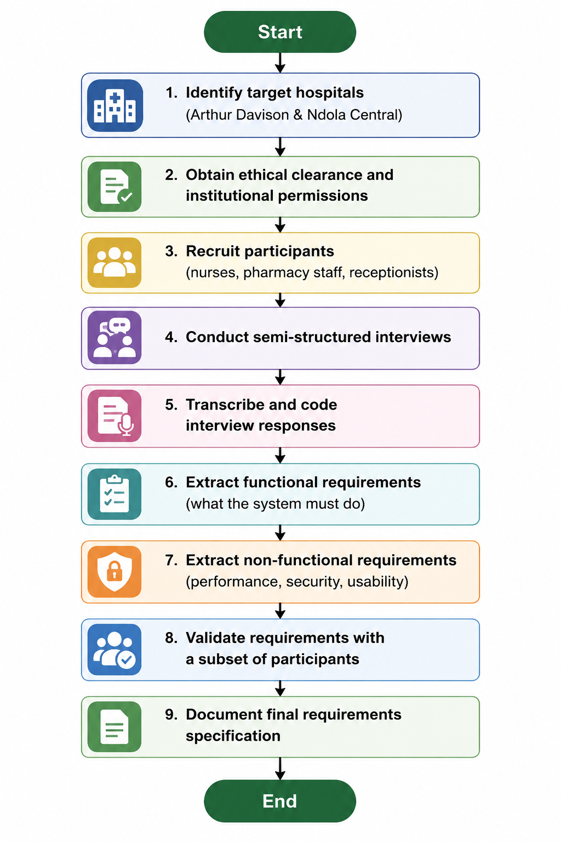
Phase 2: System Design
The researcher will create UML diagrams to direct development based on the verified requirements. Three distinct diagrams will be produced: sequence diagrams to explain how components interact to satisfy non-functional needs including timely reminder distribution and low-latency medication updates, a use case diagram to show actor-system interactions, and a class diagram to show data structure.
Use Case Diagram
- Guardians (parent or guardian): Able to register a child, make an appointment, cancel one, and verify that reminders have been sent
- Nurse: Capable of viewing the daily schedule of appointments, documenting the administration of vaccines, and designating patients as "arrived" or "no-show"
- Pharmacist: Has access to low-stock notifications, stock level updates, and predicted vaccination demand.
- Administrator of the system: able to set reminder timing, monitor system logs, and manage user accounts
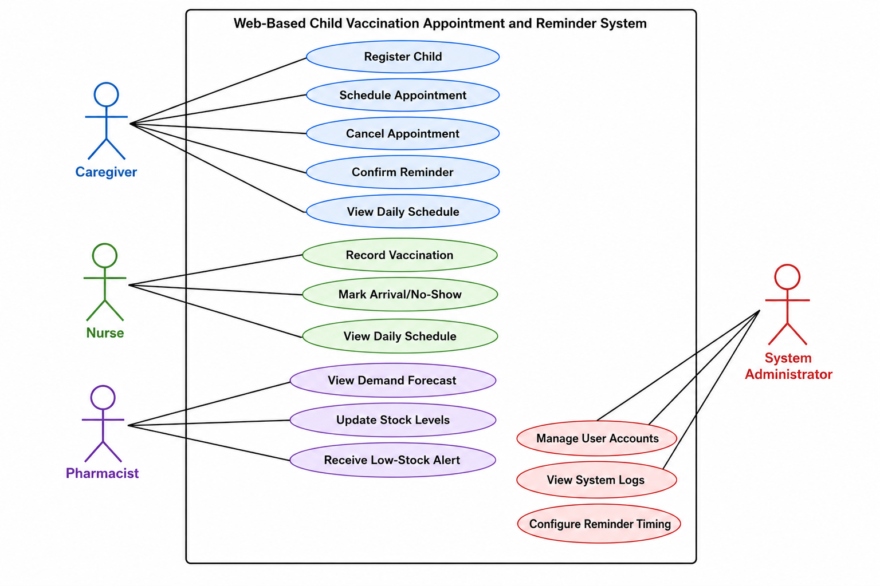
Sequence Diagram: Automated Reminder Notification (Non-Functional Requirement: Timely Delivery)
This sequence diagram will show how, even in cases where the Guardians does not actively log into the system, the system satisfies the non-functional criterion of sending reminders precisely 48 hours and two hours prior to an appointment.
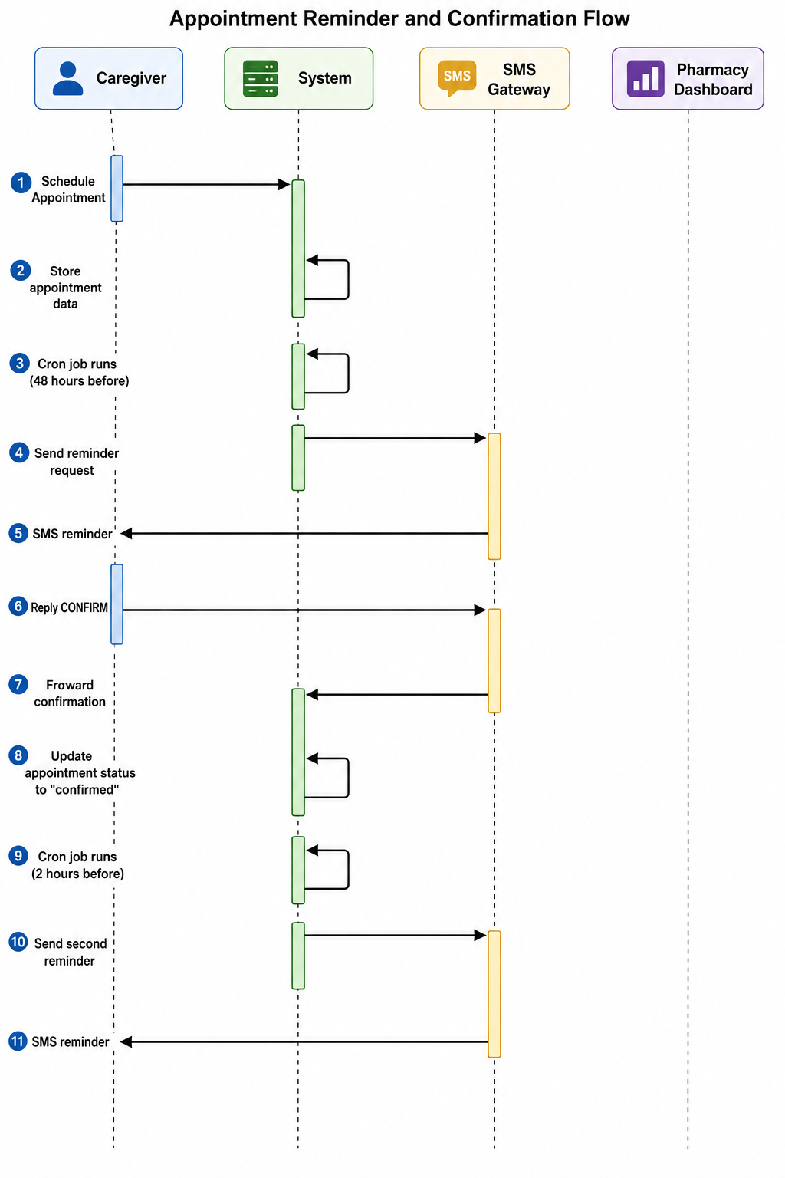
Without requiring an active Guardians login, this sequence guarantees that the non-functional criterion of timely, automated notification is satisfied.
Sequence Diagram 2: Pharmacy Demand Forecast Update (Non-Functional Requirement: Real Time Coordination)
The system satisfies the non-functional need of giving pharmacy employees real time visibility about impending vaccine demand, as seen in this sequence diagram.
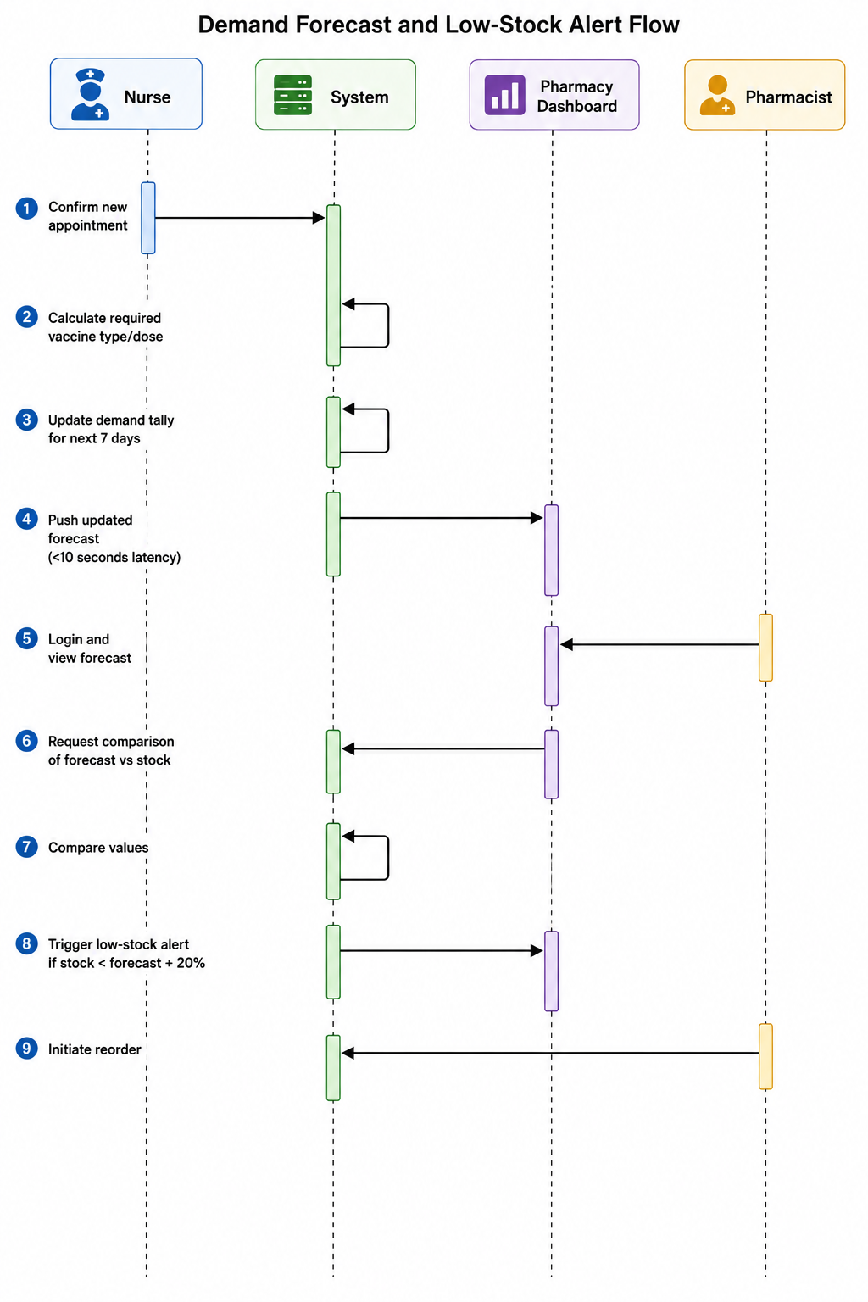
Phase 3: System Development and Testing
The system will be developed by the researcher utilizing a responsive HTML/CSS/JavaScript frontend and a XAMMP stack (Windows, Apache, MySQL, PHP). A third party gateway API (such as Twilio or Africa's Talking) will be used to provide SMS notifications. Unit testing of individual functions (such as stock calculation and reminder generation), integration testing of the scheduling and pharmacy modules' interface, and user acceptance testing involving three nurses, two pharmacists, and one administrator at Institute 1 will all be part of the testing.
Phase 4: Pre Test/Post Test Evaluation
The researcher will use a pre-test/post-test design without a control group to address the primary research question, "How can the high rate of missed immunizations be reduced?" since the intervention will be implemented in the two target hospitals one after the other. The researcher will gather baseline data on the following throughout the four week pre test phase: (a) the number of scheduled vaccination appointments; (b) the number of missed appointments (no-shows); (c) the number of vaccine stock-outs; and (d) the average patient waiting time. Every piece of information will be taken from the current paper logs and pharmaceutical records.
Research Procedure
The eight steps listed below will be followed sequentially by the researcher. Before moving on to the following step, each one must be finished.
Stage 1: Institutional and Ethical Approvals (10 days)
- Send a request for ethics to the Northrise University Research Ethics Committee.
- Await formal ethical approval. If changes are needed, finish them within three days and submit again.
- Deliver letters of introduction to Institute 2 and Institute 1.
- Meet and discuss the research with each hospital administration.
- Obtain both hospitals' signed written consent.
Stage 2: Four weeks of pre-test baseline data collection
- Make an Excel spreadsheet with the following columns: Date, Hospital, Total Arrived, Total Scheduled, Total No-Shows, and Stock-Out Occurrences.
- Access the four weeks' worth of paper appointment logbooks at Arthur Davison.
- Scheduled appointments, patients who have come, no-shows, and, if noted, the reasons for no-shows should all be counted and documented.
- Access the same four weeks' worth of pharmacy stock records. Vaccine types, opening stock, stock-out dates, and expired doses should all be noted.
- At Institute 2, repeat steps 2-4.
- For each institution, compute the baseline missing dosage rate as (Total No-Shows ÷ Total Scheduled) × 100.
Stage 3: Eliciting Requirements (Week 5)
- Create a 15 question semi structured interview guide (see Appendix A).
- Purposive sampling should be used to select 12 participants: two receptionists, four pharmacy employees, and six pediatric nurses, divided evenly across the two institutions.
- Get signed informed consent from each participant and provide them an information leaflet.
- Conduct private interviews for forty-five minutes. Take handwritten notes and, if allowed, record them on audio.
- Write a verbatim transcription of every interview.
- To extract both functional and non-functional requirements, use theme analysis.
- Make a needs specification document that is prioritized (high, medium, and low).
- Verify the requirements by asking three participants, two nurses and one pharmacist to affirm.
Stage 4 (Week 6): System Design
- Make a use case diagram with 13 use cases and 4 actors (Admin, Pharmacist, Nurse, and Guardians ).
- Make a class diagram that displays the following six database tables: User, Child, Appointment, Vaccine, Reminder, and PharmacyAlert.
- Make two sequence diagrams: one for pharmacy demand forecasting and another for automatic reminder notifications.
- Make a system architecture diagram that displays the SMS gateway and the XAMMP stack (Windows, Apache, MySQL, PHP).
Weeks 7–9 of Stage 5: System Development
- Configure the development environment with MySQL, Visual Studio Code, and XAMPP.
- Make a database that includes all six tables and their connections.
- Create the following PHP modules: (a) user registration/login; (b) appointment scheduling; (c) nurse schedule view; (d) automatic reminder generation; (e) pharmacy dashboard; and (f) reporting module.
- For reminders, incorporate the SMS gateway API (Twilio or Africa's Talking).
- Create the front end with mobile friendly responsive design utilizing HTML, CSS, and JavaScript.
Stage 6 (Week 10): System Testing
- Test each feature separately by conducting unit testing (e.g., reminder generating, stock calculation, appointment saving).
- Conduct integration testing: verify that the pharmaceutical dashboard and scheduling module are connected (expected latency <10 seconds).
- For user acceptance testing, enlist six users from Arthur Davison: three nurses, two pharmacists, and one administrator.
- Give a 30-minute system usage training session.
- Assign test scenarios, such as making and canceling appointments, updating inventory, seeing forecasts, and documenting vaccinations.
- Keep track of each scenario's success or failure. If a scenario doesn't work, fix it and try again.
- Keep a record of every test result.
Stage 7: Four weeks of post-test data collection
- For four weeks, implement the system at Institute 1.
- Daily booked appointments, confirmed appointments, no-shows, and vaccine supply levels will all be automatically recorded by the system during deployment.
- Export all post-test data from the system database into an Excel file after four weeks.
- The post-test missing dosage rate is calculated as follows: (Total No-Shows ÷ Total Scheduled) × 100.
- Determine the post test stock out rate as follows: (Days with stock-out ≥ 28 days) × 100.
- For four weeks, redeploy and gather data at Institute 2.
Stage 8: Comparison and Statistical Analysis (Week 15)
- All pre-test and post-test data should be combined into a single Excel file with two pages called "PreTest_Data" and "PostTest_Data."
- For each hospital, determine the change in missed dosage rate by subtracting the PreTest rate from the PostTest rate.
- To find out if the data are regularly distributed, do the Shapiro-Wilk test.
- Use a paired t-test to compare the pre-test and post-test means if the data are normal (p > 0.05).
- Conduct a Wilcoxon signed-rank test if the data are not normal (p < 0.05).
- Set p < 0.05 as the threshold for statistical significance.
- Calculate effect size using Cohen's d.
- Create a final study report that includes all of the findings.

Study Population and Sampling
[2- 3 paragraphs]
Two tertiary healthcare facilities in Ndola, Zambia, will serve as the study's setting: institute 1and institute 2, a sizable general teaching hospital with a dedicated pediatric ward and pharmacy department, and at institutel, the main specialized pediatric referral hospital in Copperbelt Province. Patients from Ndola City, Kitwe, Luanshya, Chingola, and rural areas are served by both hospitals. These locations were chosen due to their high patient loads, acknowledged difficulties adhering to vaccination appointments, and manual or disjointed scheduling systems. Before beginning any data collection activities, the researcher received written institutional consent from both hospitals.
All healthcare professionals that provide pediatric vaccination services, such as nurses who plan and give vaccinations, pharmacy employees who oversee vaccine inventories, and administrative staff who manage patient appointment records, make up the population of interest. The target population is defined as follows: (a) pediatric nurses who work in the immunization or outpatient departments of the two hospitals that were chosen; (b) pharmacy technicians or pharmacists who store and dispense vaccines; and (c) reception or records personnel who keep appointment logbooks. Twenty pediatric nurses, ten pharmacy employees, and five administrative staff make up the anticipated target population size of about 35 people spread across both institutions. Purposive sampling, sometimes referred to as purposeful sampling, is a non-probability sampling technique suitable for qualitative research in which the researcher deliberately chooses participants who have particular, pertinent knowledge about pharmacy coordination, patient notification procedures, and vaccination scheduling workflows. It would be impossible for participants to offer legitimate requirements for system design if they lacked firsthand, practical expertise with these procedures.
A minimum of six months of experience working in the pediatric ward or pharmacy department, weekly direct interaction with appointment scheduling or vaccine inventory, and willingness to engage in a 45-minute interview are the inclusion requirements for sample selection. Six pediatric nurses (three from each hospital), four pharmacy employees (two from each hospital), and two administrative or reception staff members (one from each hospital) make up the intended sample size of twelve.

Data Collection and Recording
[150-200 words]
The researcher will gather two kinds of data: secondary quantitative data (stock records and pre-test and post-test appointments) and primary qualitative data (healthcare workers' requirements). A semi structured interview guide (see Appendix A) with 15 open ended questions about current scheduling workflows, notification procedures, pharmacy coordination, and planned system capabilities will be used as the primary data gathering tool. With participant permission, interviews will be conducted in secret, audio recorded, and complemented by handwritten notes. Within 48 hours after each interview, the recordings will be verbatim transcribed.
The researcher will record pre test baseline data from paper logbooks and pharmacy records using a structured data extraction form in Microsoft Excel for secondary data collection. Date, total booked appointments, total arrivals, total no-shows, reasons for no-shows, vaccine supply levels, and stock-out incidents will all be recorded on the form. The web-based solution will automatically record post-test data and output it straight to Excel.
The procedures for gathering data are as follows: (1) get consent; (2) conduct and record an interview; (3) transcribe within 48 hours; (4) extract pre-test data from hospital records; (5) insert data into Excel; (6) store all data in password-protected folders; and (7) backup to an encrypted USB drive.

Validity and Reliability
[200-250 words]
The researcher will employ four distinct techniques suitable for a design science project, including qualitative requirements elicitation and quantitative pre test/post test assessment, to guarantee the validity and reliability of this study.
Triangulation of data sources comes first. Three distinct participant categories nurses, pharmacy employees, and administrative staff from two distinct hospitals will have their requirements gathered by the researcher. Cross-verification of results is made possible by this. Instead of taking one source at face value, the researcher will look into any discrepancies if nurses point out a need that pharmacy employees fail to note.
Member checking comes in second. The participant will receive a summary of their answers from the researcher within a week of each interview being transcribed. "Does this accurately reflect what you intended to say?" will be the question posed to the participant. Any explanations or adjustments will be added right away. This guarantees that participant opinions are appropriately reflected in the collected data.
The audit trail comes in third. Every choice, action, and change made throughout the study will be recorded in a thorough research log kept by the investigator. Interview dates, transcribing completion times, interview guide modifications, and explanations for any process deviations will all be recorded in this log. This log can be examined by an impartial researcher to confirm that the study was carried out methodically.
Member checking comes in second. The participant will receive a summary of their answers from the researcher within a week of each interview being transcribed. "Does this accurately reflect what you intended to say?" will be the question posed to the participant. Any explanations or adjustments will be added right away. This guarantees that participant opinions are appropriately reflected in the collected data.
The audit trail comes in third. Every choice, action, and change made throughout the study will be recorded in a thorough research log kept by the investigator. Interview dates, transcribing completion times, interview guide modifications, and explanations for any process deviations will all be recorded in this log. This log can be examined by an impartial researcher to confirm that the study was carried out methodically.

Research Project Limitations
[1 – 2 paragraphs]
This research may be impacted by a number of limitations. Limited generalizability is the first. Only two hospitals in Ndola, Zambia, will be used for the study. The results might not be applicable to other medical facilities in various areas, rural areas, or nations with different infrastructure, patient demographics, or resource levels. In order to reduce this, the researcher will give readers thorough explanations of the study environments, participant traits, and local context so they can evaluate transferability to their own contexts. The Hawthorne effect comes in second.
The Hawthorne effect comes in second. When healthcare professionals are aware that they are being watched or interviewed, they may behave differently and give idealistic answers instead of detailing real-world procedures. In order to reduce this, the researcher will spend casual time in the wards prior to formal data collection. This will allow staff to become used to the researcher's presence and reassure participants that there are no right or incorrect answers.
Third, a brief post-test period. Due to the short post test data collection period of four weeks per hospital, long-term system adoption patterns and seasonal fluctuations in vaccine attendance may not be captured. The researcher will recognize this restriction and suggest longitudinal follow-up studies as future study in order to reduce it. Fourth, using data that is self-reported. Participants' honesty and recollection are key factors in interview responses. In order to reduce this, the researcher would, if feasible, cross-check interview claims against observed workflows and current paper records; any discrepancies will be openly reported in the final report.

Delimitations
[2 – 3 paragraphs]
The scheduling of pediatric vaccinations at Institute 1 and Institute 2 in Ndola, Zambia, will be the exclusive subject of this study. Because vaccination schedules have certain timing needs and adherence issues that are different from other appointment types, the study will not include other sorts of appointments (such as general outpatient consultations, laboratory visits, or follow-up for chronic conditions). In order to maintain a narrow scope that enables in-depth investigation of pediatric immunization operations, the researcher purposefully leaves out private clinics and adult vaccination services. This delimitation is required since the time and resource limits of this research study would not allow for the inclusion of multiple appointment kinds, which would require separate notification tactics, pharmacy integration rules, and data collection devices.
The kinds of participants in requirements elicitation will also be limited by the study. This will only cover pediatric nurses, pharmacy employees, and administrative personnel who deal directly with vaccination appointments or vaccine inventory. Neither hospital executive management nor Guardians s (parents or guardians) will be interviewed for the study. Although the researcher agrees that future research should include Guardians viewpoints, Guardians s are left out because the main focus is on workflow and system requirements from the perspective of healthcare providers. Hospital executives are not included since they are unable to provide specific functional requirements for system design because they do not handle daily scheduling or inventory chores. This delimitation guarantees that every need gathered is based on practical operational experience.
Lastly, a XAMMP stack (Windows, Apache, MySQL, PHP) will be used to construct the web-based system, and a third-party gateway will be used to transmit SMS notifications. Because web-based solutions provide cross-platform accessibility without requiring different codebases or app store approvals, the study will not create native mobile applications (iOS or Android). Additionally, since billing and electronic health record integration are outside the purview of lowering missed immunization doses and enhancing pharmacy coordination, they will not be included in the system.

Ethical Consideration
[2- 3 paragraphs]
The ethical standards established by Northrise University and the Zambian National Health Research Authority will be followed in this study. Informed consent comes first. A participant information sheet outlining the research's objectives, methods, duration (45 minutes), risks (minimal, including possible discomfort discussing workflow challenges), benefits (none directly, but the system may improve future working conditions), and their right to withdraw at any time without penalty will be given to each prospective participant prior to the start of data collection. Each participant will provide written informed consent to the researcher using a consent form that outlines these components. The information will be read aloud to participants who are illiterate in either Bemba or English, and a witness will record their verbal permission.
Data storage and confidentiality come in second. The researcher's personal computer will store all interview recordings, transcriptions, and extracted data in password-protected folders. An encrypted USB drive stored in a locked drawer at home will serve as a backup. Each participant will be given a unique code (e.g., NURSE01, PHARM02, ADMIN03), and their names will not appear in any transcript or report. After the study is finished, the master list that connects codes to names will be deleted and kept apart from all other data. Although no specific staff member will be identified, hospital names will be revealed in the final report since the context is important for understanding the results.
Third, preventing damage and guaranteeing privacy. Participants won't suffer any bodily or psychological harm, according to the researcher. On the other hand, some inquiries concerning workflow inefficiencies could be somewhat embarrassing or frustrating. The researcher will remind participants that the objective is to enhance systems, not to assess individual performance, in order to address this. All information will be reported either anonymised or in aggregate form. Before the final analysis, participants will have the chance to go over their own interview summaries and ask that any statements that make them uncomfortable be removed.
In compliance with the criteria established by the Northrise University Research Ethics Committee (NUREC) and the National Health Research Authority (NHRA), participants in this study will not be compensated for their participation in any way. In order to protect the integrity of the research findings and avoid any undue influence or pressure that would jeopardize the voluntary character of participation, this policy is closely followed.All potential participants will receive the Participant Information Sheet and the Informed Consent Form, which both clearly explain the researcher's policy. According to NHRA standards, this policy only applies to contracted data collectors, consultants, or local guides none of whom are involved in this study. The researcher will make the necessary changes to this protocol to guarantee continued compliance in the event that NHRA creates a formal mechanism for participant pay in the future.
Dissemination of Results
Several stakeholders will be informed of the research's conclusions in order to promote accountability, openness, and knowledge sharing. The following methods of distribution will be used:
First, in order to partially fulfill the requirements for a bachelor's degree, the entire research project report will be sent to the Department of Information Technology at Northrise University. The final report will be made freely available to students, staff, researchers, and the general public by depositing an electronic copy in the Northrise University research repository or institutional server. This guarantees that the results add to the body of knowledge about digital health initiatives in Zambia.
Second, institute 1 and institute 2, the collaborating healthcare facilities, will receive a condensed, non technical report of the research findings. To ensure that people who contributed to the study are aware of the results and may profit from the insights produced, this report will be given to hospital administration, pediatric department heads, pharmacy management, and participating healthcare professionals. For part of the researcher will draft a succinct summary of the results. This synopsis will be distributed via a straightforward one-page handout or at a quick feedback session, recognizing their important contributions and explaining how their input influenced the system's design.
In order exchange policymakers, a summary of the results will be presented at a pertinent academic forum or conference, such as a Northrise University research symposium or a Zambian public health conference.
Conflict of Interest Disclosure
The researcher, Augustine Nguzayikona, hereby declares that there are no financial, personal, professional, or organizational conflicts of interest that could influence the design, conduct, analysis, interpretation, or reporting of this research. The study is conducted solely for academic purposes as a partial fulfillment of the requirements for the Bachelor of Information Technology in Web and Software Development degree at Northrise University.
The researcher or commercial goods, services, or businesses that would profit from the study's findings. The researcher has no ties with pharmaceutical companies, technology vendors, or vaccine makers that would present a conflict of interest, and no outside funding has been obtained for this study.
The researcher's pediatric healthcare delivery by creating a digital health solution that is fit for the local context. The results shall be presented truthfully and openly, with no effort to conceal, alter, or portray facts in a way that would support a specific conclusion. The Northrise University Research Ethics Committee shall be quickly informed of any potential conflicts that may occur during the research.

Conclusion
[200- 250 words]
A thorough research methodology for the creation and assessment of a Web Based Vaccination Scheduling and Notification System with Pharmacy Integration at institute 1 and institute 2, Zambia, has been provided in this chapter. In order to address the primary research question, "How can the high rate of missed immunizations in Ndola, Zambia, particularly in the pediatric ward?" the study will use a design science approach in conjunction with a pre-test/post-test design
The eight step study process, from securing ethical permissions to statistical analysis, was described in depth in this chapter. Semi-structured interviews will be used to gather primary data from 12 purposively sampled participants (administrative, pharmacy, and pediatric nurses) in order to extract both functional and non-functional system requirements. A 4 week pre-test phase and a 4-week post-test phase after system deployment will be used to gather secondary data on vaccination stock levels and appointment adherence. Triangulation of data sources, member verification, audit trails, and instrument pilot testing will all be used to guarantee validity and dependability. The Hawthorne effect, short post-test period, limited generalizability, and dependence on self-reported data are some of the limitations that have been addressed using particular mitigation techniques. The study is limited to pediatric vaccine scheduling at two hospitals; native mobile app development, Guardians viewpoints, and other appointment kinds are not included. Informed permission, data preservation, confidentiality, and minimizing harm are among ethical issues that have been thoroughly described. When taken as a whole, this methodology offers a rigorous, repeatable framework for assessing whether the suggested web-based system will enhance pharmacy coordination in Zambia's pediatric healthcare settings and result in a measurable decrease in missed immunization doses.

References
PATH. (2025). From paper to digital: Reinventing Zambia's community health care efficiency. PATH. https://www.path.org/our-impact/articles/from-paper-to-digital-reinventing-zambias-community-health-care-efficiency/
Simwanza, J., et al. (2025). From paper to digital: Lessons from Zambia's immunisation campaigns for equity and sustainability. ScienceDirect. https://www.sciencedirect.com/science/article/pii/S3050501125000021
Osei, E., et al. (2026). Beyond technology: Understanding digital healthcare through patient experience and sociotechnical resilience in Northern Ghana. ScienceDirect, *9*, 100319. https://www.sciencedirect.com/science/article/pii/S2772653326000444
O'Connor, Y., O'Sullivan, T., Gallagher, J., Heavin, C., Hardy, V., & O'Donoghue, J. (2018). A mobile health technology intervention for addressing the critical public health issue of child mortality. The Electronic Journal of Information Systems in Developing Countries, *84*(1). https://doi.org/10.1002/isd2.12011
Yunusa, U., Garba, S. N., MacDonald, S. E., et al. (2024). Utilization of Mobile Reminders in Improving the Completeness and Timeliness of Routine Childhood Immunization in Kano Metropolis, Nigeria: A Randomized Controlled Trial. Journal of Pediatric Health Care, *38*(5), 727-736. https://doi.org/10.1016/j.pedhc.2024.03.002
Woldie, M., et al. (2019). Development of automated text-message reminder system to improve uptake of child vaccination in Ethiopia. Online Journal of Public Health Informatics, *11*(2), e15. http://ojphi.org
Jaleha, J., Widjarnarko, B., Susanto, H. S., et al. (2023). Assessing Interventions for Declining Childhood Immunization Dropout - A Systematic Review. JURNAL INFO KESEHATAN, *21*(3), 438-453.
Population Services International. (2026). Beyond the Counter: Building the Frontline Workforce for the Future of Immunization. PSI. https://www.psi.org/fr/2026/06/beyond-the-counter-building-the-frontline-workforce-for-the-future-of-immunization/
Mollel, H. A., et al. (2025). Uptake, scale up, integration of vaccine, immunization, and health supply chain management technologies and innovation into policy: experience from Tanzania. BMC Health Services Research, *25*, 306. https://doi.org/10.1186/s12913-025-12383-8
Currie, G. E., McLeod, C., Waddington, C., & Snelling, T. L. (2024). SMS-based interventions for improving child and adolescent vaccine coverage and timeliness: A systematic review. BMC Public Health, 24(1), 1753. https://doi.org/10.1186/s12889-024-18900-4
Filimonau, V. (2023). The cost-effectiveness of digital health interventions in low-resource settings. Health Policy and Technology, 12(1), 100712.
Ford, C., & Sturman, N. (2023). Mobile-based appointment systems in primary healthcare: A scoping review. BMJ Health & Care Informatics, 30(1), e100689.
Indonesia IIS Prototype Design. (2023). Integrated Immunization Information System in Indonesia: Prototype Design Using Quantitative and Qualitative Data. ScienceDirect. https://www.sciencedirect.com/org/science/article/pii/S2561326X23006054
Jaleha, J., Widjarnarko, B., Susanto, H. S., et al. (2023). Assessing Interventions for Declining Childhood Immunization Dropout - A Systematic Review. JURNAL INFO KESEHATAN, 21(3), 438-453.
Ministry of Health, Republic of Zambia. (2021). National health strategic plan 2021–2025. Government Printer.
Mollel, H. A., et al. (2025). Uptake, scale up, integration of vaccine, immunization, and health supply chain management technologies and innovation into policy: experience from Tanzania. BMC Health Services Research, 25, 306. https://doi.org/10.1186/s12913-025-12383-8
O'Connor, Y., O'Sullivan, T., Gallagher, J., Heavin, C., Hardy, V., & O'Donoghue, J. (2018). A mobile health technology intervention for addressing the critical public health issue of child mortality. The Electronic Journal of Information Systems in Developing Countries, 84(1). https://doi.org/10.1002/isd2.12011
Osei, E., et al. (2026). Beyond technology: Understanding digital healthcare through patient experience and sociotechnical resilience in Northern Ghana. ScienceDirect, 9, 100319. https://www.sciencedirect.com/science/article/pii/S2772653326000444
PATH. (2025). From paper to digital: Reinventing Zambia's community health care efficiency. PATH. https://www.path.org/our-impact/articles/from-paper-to-digital-reinventing-zambias-community-health-care-efficiency/
Population Services International. (2026). Beyond the Counter: Building the Frontline Workforce for the Future of Immunization. PSI. https://www.psi.org/fr/2026/06/beyond-the-counter-building-the-frontline-workforce-for-the-future-of-immunization/
Simwanza, J., et al. (2025). From paper to digital: Lessons from Zambia's immunisation campaigns for equity and sustainability. ScienceDirect. https://www.sciencedirect.com/science/article/pii/S3050501125000021
World Health Organization. (2022). Global immunization coverage report 2022. World Health Organization.
Woldie, M., et al. (2019). Development of automated text-message reminder system to improve uptake of child vaccination in Ethiopia. Online Journal of Public Health Informatics, 11(2), e15. http://ojphi.org
Yunusa, U., Garba, S. N., MacDonald, S. E., et al. (2024). Utilization of Mobile Reminders in Improving the Completeness and Timeliness of Routine Childhood Immunization in Kano Metropolis, Nigeria: A Randomized Controlled Trial. Journal of Pediatric Health Care, 38(5), 727-736. https://doi.org/10.1016/j.pedhc.2024.03.002

Appendices
Present the appendices after the references. Data collection tools like questionnaires and interview guides come here. The sectional heading “Appendices” or “Appendix” (if only one appendix exists) should be formatted to normal so that it does not appear in the table of contents. What should appear in the table of contents are the individual actual appendices. Because the appendix label (e.g. Appendix A.) and the appendix title (e.g. Interview Guide) appear on separate lines, just format the label to heading 1 and the title to normal but enter the title manually in the table of contents, e.g. Appendix A. Interview Guide. Remember to adhere to APA guidelines in identifying, naming and numbering the appendices. If a particular appendix begins with text, the text must begin with paragraph indentation as usual. Appendices should have their own sub headings apart from the main first level heading “Appendices”. If there is only one appendix in the document, use the word “Appendix” instead of “Appendices” for the section first level heading.
Appendices should have labels starting from “Appendix A” onwards (using uppercase of the alphabet A to Z). The appendices labels should be set to heading level 1. Each appendix should be presented on a new page.

Appendix A
Interview Guide

Reproduce your interview guide here. Not in a box of course. Reproduce it the way it was during the proposal.

Web-Based Vaccination Scheduling and Notification System with Pharmacy Integration
This interview guide is administered one on one to twelve purposely sampled participants: six pediatric nurses, four pharmacy staff, and two receptionist/administrative staff from Arthur Davison Children's Hospital and Ndola Central Teaching Hospital.
Instructions for the Interviewer
- Confirm that the participant has signed the Informed Consent Form before beginning.
- Remind the participant that the interview will take approximately 45 minutes, participation is voluntary, and they may withdraw at any time.
- Request permission to audio-record the session.
- Assign a unique participant code (e.g., NURSE01, PHARM02, ADMIN01).
- Ask questions in order, but allow natural conversation.
Opening Script
"Thank you for agreeing to speak with me today. I am researching how vaccination appointment scheduling, patient reminders, and pharmacy stock coordination currently work at this hospital. There are no right or wrong answers. I am interested in your honest experience. Everything you say will be treated confidentially. May we begin?"
Section 1: Participant Information

Field | Response
Participant Code
Role
Facility
Years of experience
Date of interview

Section 2: Interview Questions
Q1. Could you briefly describe your role and day-to-day responsibilities in relation to pediatric vaccination appointments?
Q2. Please walk me through, step by step, how a caregiver currently books, reschedules, or cancels a vaccination appointment at this facility.
Probe: Who is involved? What records are used?
Q3. What tools or records — logbooks, registers, or spreadsheets — are currently used to manage the appointment schedule?
Q4. What challenges or bottlenecks do you experience with the current scheduling process?
Q5. How are caregivers currently reminded about upcoming vaccination appointments?
Q6. In your experience, how often do caregivers miss scheduled appointments, and what reasons do they usually give?
Q7. What follow-up process, if any, takes place when a caregiver misses an appointment?
Q8. How do you currently determine how many vaccine doses to keep in stock? [Pharmacy staff focus]
Q9. How and when does the pharmacy department find out about upcoming vaccination appointments? [Pharmacy staff focus]
Closing
"Thank you very much for your time. I will share a short summary of your responses within a week so you can confirm it reflects what you intended to say."

Appendix B

Type the SQL code here. Not in a box, just the SQL code.
SQL for Creating the Signing Table

-- ============================================================

-- Database: vaccination_system

-- Table: signing_records

-- Description: Stores participant sign-in and consent confirmation records

-- ============================================================

CREATE DATABASE IF NOT EXISTS vaccination_system;

USE vaccination_system;

-- ------------------------------------------------------------

-- Table structure for signing_records

-- ------------------------------------------------------------

CREATE TABLE IF NOT EXISTS signing_records (

signing_id INT(11) NOT NULL AUTO_INCREMENT,

participant_code VARCHAR(20) NOT NULL,

participant_role ENUM('Nurse', 'Pharmacy', 'Admin-Reception') NOT NULL,

facility VARCHAR(100) NOT NULL,

consent_given ENUM('Yes', 'No') NOT NULL DEFAULT 'No',

consent_date DATE NOT NULL,

interview_date DATE,

audio_recorded ENUM('Yes', 'No') DEFAULT 'No',

signature_path VARCHAR(255),

created_at TIMESTAMP NOT NULL DEFAULT CURRENT_TIMESTAMP,

updated_at TIMESTAMP NOT NULL DEFAULT CURRENT_TIMESTAMP ON UPDATE CURRENT_TIMESTAMP,

PRIMARY KEY (signing_id),

UNIQUE KEY unique_participant_code (participant_code)

) ENGINE=InnoDB DEFAULT CHARSET=utf8mb4 COLLATE=utf8mb4_unicode_ci;

-- ------------------------------------------------------------

-- Sample INSERT statement for adding a participant record

-- ------------------------------------------------------------

INSERT INTO signing_records (

participant_code,

participant_role,

facility,

consent_given,

consent_date,

interview_date,

audio_recorded,

signature_path

) VALUES (

'NURSE01',

'Nurse',

'Arthur Davison Children\'s Hospital',

'Yes',

'2026-07-01',

'2026-07-03',

'Yes',

'uploads/signatures/NURSE01_sig.png'

);

-- ------------------------------------------------------------

-- Query to retrieve all signed consent records

-- ------------------------------------------------------------

SELECT

signing_id,

participant_code,

participant_role,

facility,

consent_given,

consent_date,

interview_date,

audio_recorded

FROM signing_records

WHERE consent_given = 'Yes'

ORDER BY consent_date DESC;

-- ------------------------------------------------------------

-- Query to count participants by role

-- ------------------------------------------------------------

SELECT

participant_role,

COUNT(*) AS total_participants

FROM signing_records

WHERE consent_given = 'Yes'

GROUP BY participant_role;

-- ------------------------------------------------------------

-- Query to retrieve participants by facility

-- ------------------------------------------------------------

SELECT

facility,

COUNT(*) AS total_signed,

SUM(CASE WHEN consent_given = 'Yes' THEN 1 ELSE 0 END) AS consented

FROM signing_records

GROUP BY facility;

Appendix C
Research Budget
This study shows that follows. All sums are estimations based on current market pricing in Ndola, Zambia, and the researcher is self-funding this project.

Item | Description | Unit cost  (ZMW) | Quantity | Total  (ZMW)
Transport | Local travel from residence to Institute 1 (10 trips) | 40.00 | 10 | 400.00
Transport | Local travel from residence to Institute 2 (10 trips) | 40.00 | 10 | 400.00
Communication | Airtime for phone calls to coordinate interviews and hospital visits | 100.00 | 2 | 100.00
Communication | Mobile data for research-related online activities and system testing | 150.00 | 1 | 150.00
Printing & Stationery | Printing of Participant Information Sheets and Informed Consent Forms | 2.00 | 20 | 40.00
Printing & Stationery | Printing of Interview Guides and Data Extraction Forms | 2.00 | 15 | 30.00
Printing & Stationery | Binding and Printing of final research report | 80.00 | 2 | 160.00
Total Estimated Budget |  |  |  | 1280.00

Note: Leave the last page blank

